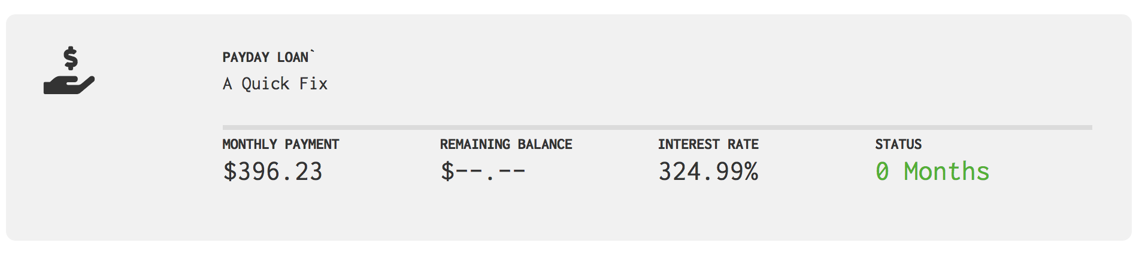

Edit

1. Remove “Update or Add Sources” on dashboard (Chris)
2. Add “Edit” in the top right corner. When a user clicks on Edit, he/she should be taken to“debt-sources-modify.php” (Chris)
3. Debt-sources-modify.php then loads only the card that the user selected. User can then Save and go back to dashboard or Cancel and go back to dashboard. (Ravi)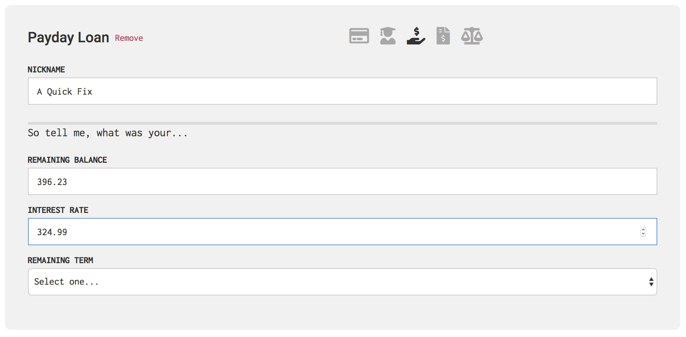

4. Figure out how to populate dashboard based on our algorithm/engine (Ravi)